ICT 2105: Numerical Analysis
Newton-Raphson Method

Let x₀ be an approximate root of the equation f(x) = 0
and
Let x = x₀ + h be an exact root so that f(x₀ + h) = 0, where h being a small quantity.
Now expanding f(x₀ + h) by Taylor’s series, we get –

f(x₀ + h) = f(x₀) + hf’(x₀) + $\frac{h^{2}}{2!}$ hf’’(x₀) + …….

$∴$ f(x₀) + hf’(x₀) + $\frac{h^{2}}{2!}$ f’’(x₀) = 0 ∵ x₀ + h = 0

Since h is very small, neglecting the second and higher order terms of h, we obtain an approximate value of h say h from the above equation.

$∴$ f(x₀) + h₁f’(x₀) = 0 ⇒ h₁ = - $\frac{f(x_{0})}{f'(x_{0})}$ ………. …. (1)

A better approximation than x₀ is therefore may lie at x₁ where

x₁ = x₀ + h₁

$∴$ x₁ = x₀ - $\frac{f(x_{0})}{f'(x_{0})}$ ………….. from (1)

Now using x₁ in the place of x₀ and x₂ in the place of x₁ we get

Now replace x₁ for x₀
and x₂ for x₁

x₂ = x₁ - $\frac{f(x_{1})}{f'(x_{1})}$ , which is little better than before e.g. x₁.

Similarly

X₃ = x₂ - $\frac{f(x_{2})}{f'(x_{2})}$ , which is little better than x₂.

….. …… …… …… ……. ……. ……. ……
….. …… …… …… ……. ……. ……. ……

Continuing like this, we iterate this process until

X_{n+1} = x_{n} - $\frac{f(x_{n})}{f'(x_{n})}$ , where n = 0,1,2,3,………

This method of successive approximation is called the Newton-Raphson Method.

The method can be used for both algebraic and transcendental equations and works for complex equation with complex coefficients.

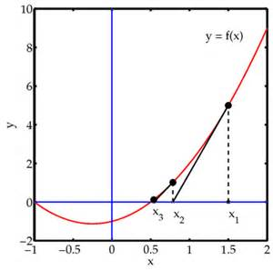

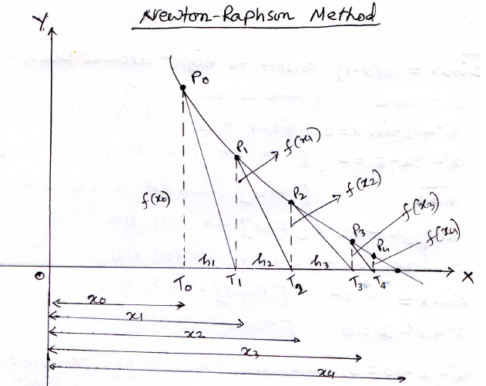

Examples of NR(Newton-Rapson Method):

Ex-1: Find the root of ${ 2x}^{3}-3x-6=0$ by NR method correct to five decimal places.
Solution: let, $f\left(x\right)=2x^{3}-3x-6 so, f^{'}\left(x\right)=6x^{2}-3$
$$here, f\left(1\right)=-7<0 ; f\left(2\right)=4>0$$
So, at least one root lies between 1 and 2. $⇒x_{0}=1.5$
Now by NR method, we get:
$$x_{n+1}=x_{n}-\left(\frac{f\left(x_{n}\right)}{f^{'}\left(x_{n}\right)}\right)=x_{n}-\frac{2x_{n}^{3}-3x_{n}-6}{6x_{n}^{2}-3}=\frac{6x_{n}^{3}-3x_{n}-2x_{n}^{3}+3x_{n}+6}{6x_{n}^{2}-3}$$
$$⇒x_{n+1}=\frac{4x_{n}^{3}+6}{6x_{n}^{2}-3}……………………..\left(1\right)$$
From (1) putting $x_{0}=1.5$we get,
$$x_{1}=\frac{4x_{0}^{3}+6}{6x_{0}^{2}-3}=\frac{4{\left(1.5\right)}^{3}+6}{6{\left(1.5\right)}^{2}-3}=1.85714$$
$$x_{2}=\frac{4x_{1}^{3}+6}{6x_{1}^{2}-3}=\frac{4{\left(1.85714\right)}^{3}+6}{6{\left(1.85714\right)}^{2}-3}=1.78711$$
$$x_{3}=\frac{4x_{2}^{3}+6}{6x_{2}^{2}-3}=\frac{4{\left(1.78711\right)}^{3}+6}{6{\left(1.78711\right)}^{2}-3}=1.78373$$
$$x_{4}=\frac{4x_{3}^{3}+6}{6x_{3}^{2}-3}=\frac{4{\left(1.78373\right)}^{3}+6}{6{\left(1.78373\right)}^{2}-3}=1.78377$$
$$x_{5}=\frac{4x_{4}^{3}+6}{6x_{4}^{2}-3}=\frac{4{\left(1.78377\right)}^{3}+6}{6{\left(1.78377\right)}^{2}-3}=1.78377$$
Hence, the required root is 1.78377.

Ex-2: Find the root of $x^{3}=6x-4$ correct to Five decimal places by NR method.
Solution: let, $f\left(x\right)=x^{3}-6x+4 so, f^{'}\left(x\right)=3x^{2}-6$
Here, f(0)=4>0 and f(1)=-1<0 .
So, at least one root lies between o and 1.$⇒x_{0}=0.75$
Now, by NR method we get,
$$x_{n+1}=x_{n}-\frac{f\left(x_{n}\right)}{f^{'}\left(x_{n}\right)}=x_{n}-\frac{x_{n}^{3}-6x_{n}+4}{3x_{n}^{2}-6}=\frac{2x_{n}^{3}-4}{3x_{n}^{2}-6}………….\left(1\right)$$
Taking $x_{0}=0.75$ the relation (1) gives,
$$x_{1}=\frac{2{\left(x_{0}\right)}^{3}-4}{3{\left(x_{0}\right)}^{2}-6}=\frac{2{\left(0.75\right)}^{3}-4}{3{\left(0.75\right)}^{2}-6}=0.72188$$
$$x_{2}=\frac{2{\left(x_{1}\right)}^{3}-4}{3{\left(x_{1}\right)}^{2}-6}=\frac{2{\left(0.72188\right)}^{3}-4}{3{\left(0.72188\right)}^{2}-6}=0.73205$$
$$x_{3}=\frac{2{\left(x_{2}\right)}^{3}-4}{3{\left(x_{2}\right)}^{2}-6}=\frac{2{\left(0.73205\right)}^{3}-4}{3{\left(0.73205\right)}^{2}-6}=0.73205$$
so, the required root is$0.73205$ .
Ex-3 Find the root of 3x-cosx-1=0 by Newton-Raphson method correct to six decimal places.
Solution: Let, f(x) =3x-cosx-1
So, f ’(x) = 3+sinx
Here, f(0) = 0-0-1 <0
And f(1) = 3-cos(1)-1 = 1.45970 >0
So, one root lies between 0 and 1.
Now, by NR method we get:
$$x_{n+1}=x_{n}-\frac{f\left(x_{n}\right)}{f^{'}\left(x_{n}\right)}=x_{n}-\frac{3x_{n}-\cos{x_{n}}-1}{3+\sin{x_{n}}}=\frac{x_{n}\sin{x_{n}}+\cos{x_{n}}+1}{3+\sin{x_{n}}}…………….\left(1\right)$$
Taking $x_{0}=0.5$ the relation (1) gives,
$$x_{1}=\frac{x_{0}\sin{x_{0}}+\cos{x_{0}}+1}{3+\sin{x_{0}}}=\frac{0.5\sin\left(0.5\right)+\cos\left(0.5\right)+1}{3+\sin\left(0.5\right)}=0.60852$$
$$x_{2}=\frac{x_{1}\sin{x_{1}}+\cos{x_{1}}+1}{3+\sin{x_{1}}}=\frac{0.60852\sin\left(0.60852\right)+\cos\left(0.60852\right)+1}{3+\sin\left(0.60852\right)}=0.60710$$
$$x_{3}=\frac{x_{2}\sin{x_{2}}+\cos{x_{2}}+1}{3+\sin{x_{2}}}=\frac{0.60710\sin\left(0.60710\right)+\cos\left(0.60710\right)+1}{3+\sin\left(0.60710\right)}=0.60710$$
So, The required root is: $0.60710$.
Ex-4: Find the root of $\cos{x}-xe^{x}=0$ by NR.
Solution:
Let, $f\left(x\right)=\cos{x}-xe^{x} so, f^{'}\left(x\right)=-\sin{x}-e^{x}-xe^{x}$
Here, f(0)=1>0 and f(1)=-2.17798<0 so, one root lies between 0 and 1.
By NR method we get,
$$x_{n+1}=x_{n}-\frac{f\left(x_{n}\right)}{f^{'}\left(x_{n}\right)}=x_{n}-\frac{\cos{x_{n}}-x_{n}e^{x_{n}}}{-\sin{x_{n}}-e^{x_{n}}-x_{n}e^{x_{n}}}=\frac{x_{n}\sin{x_{n}}+x_{n}^{2}e^{x_{n}}+\cos{x_{n}}}{\sin{x_{n}}+e^{x_{n}}+x_{n}e^{x_{n}}}……(1)$$
Taking $x_{0}=0.5$ we get from (1)
$$x_{1}=\frac{x_{0}\sin{x_{0}}+x_{0}^{2}e^{x_{0}}+\cos{x_{0}}}{\sin{x_{0}}+e^{x_{0}}+x_{0}e^{x_{0}}}=\frac{0.5\sin{0.5}+{0.5}^{2}e^{0.5}+\cos{0.5}}{\sin{0.5}+e^{0.5}+0.5e^{0.5}}=0.51803$$
$$x_{2}=\frac{x_{1}\sin{x_{1}}+x_{1}^{2}e^{x_{1}}+\cos{x_{1}}}{\sin{x_{1}}+e^{x_{1}}+x_{1}e^{x_{1}}}=\frac{0.51803\sin{0.51803}+{0.51803}^{2}e^{0.51803}+\cos{0.51803}}{\sin{0.51803}+e^{0.51803}+0.51803e^{0.51803}}=0.51776$$
$$x_{3}=\frac{x_{2}\sin{x_{2}}+x_{2}^{2}e^{x_{2}}+\cos{x_{2}}}{\sin{x_{2}}+e^{x_{2}}+x_{2}e^{x_{2}}}=\frac{0.51776\sin{0.51776}+{0.51776}^{2}e^{0.51776}+\cos{0.51776}}{\sin{0.51776}+e^{0.51776}+0.51776e^{0.51776}}=0.51776$$
So the required root is: $0.51776.$

Exercise for NR method:
- $\sin{x}=10(x-1)$ correct to eight decimal places ⇒ f(1),f(2)
- $x=\cos{x}$ [five decimal] ⇒ f(0), f(1)
- $x^{2}+4\sin{x}=0$ [Four decimal] ⇒ f(-1), f(-2)
- $x^{3}-3x-5=0$ [Four decimal] ⇒ f(2), f(3)
- $\sqrt{30} ;(let x=\sqrt{30} ⇒x^{2}=30⇒x^{2}-30=0)$ [Five decimal] ⇒ f(5), f(6)
- $xlog_{10}x-1.2=0$ [Five decimal] ⇒ f(2), f(3)
- $2x-3\sin{x}-5=0$ [Six decimal] ⇒ f(1), f(2)
- $\sin{x}=1-x^{2}$ [Eight decimal] ⇒ f(0), f(1)
- $x^{4}+x^{2}-80=0$ [Three decimal] ⇒ f(2), f(3)
- $x^{4}-x-10=0$, where/which is near to x=2 [Three decimal] ⇒ f(1), f(2)

